Courier management system

Activity 1: Creating a Tab for Customer Object

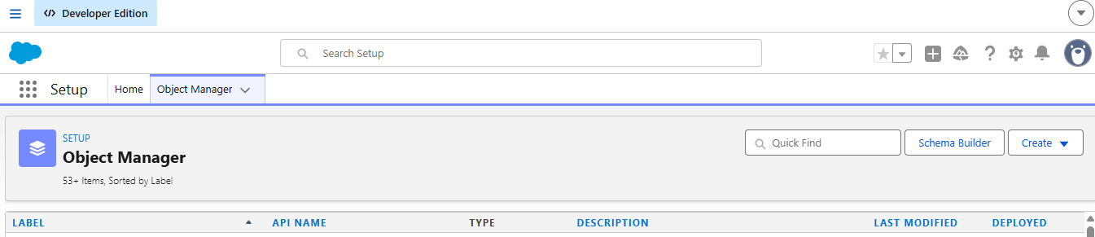

Activity 2: Creating a Tab for Shipment Object

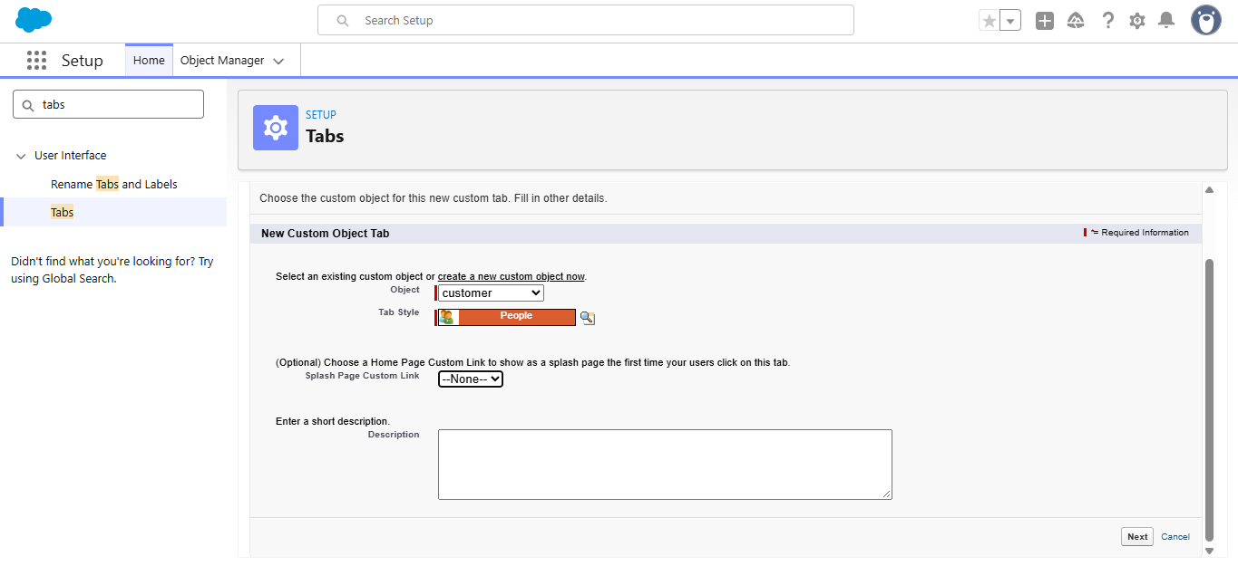Activity 3: Creating a Tab for Delivery Agent Object
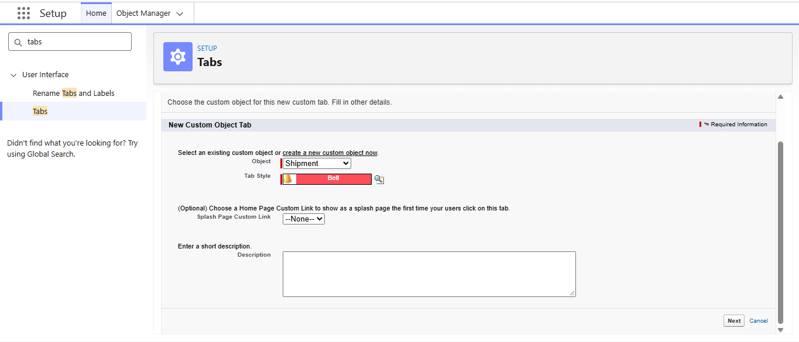

Activity 4: Creating a Tab for Branch Object
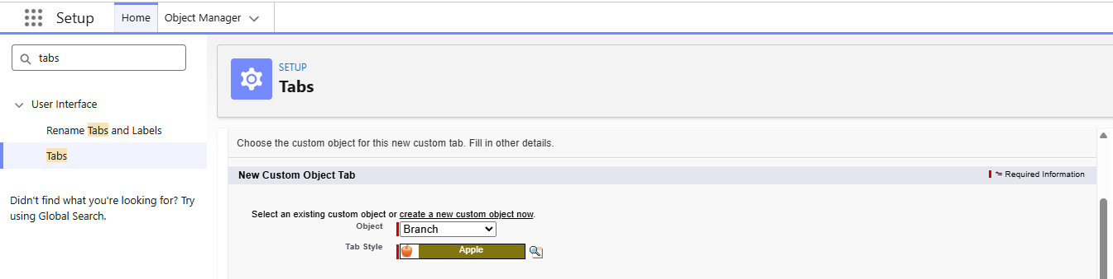

Activity 5: Creating a Tab for Delivery Update Object
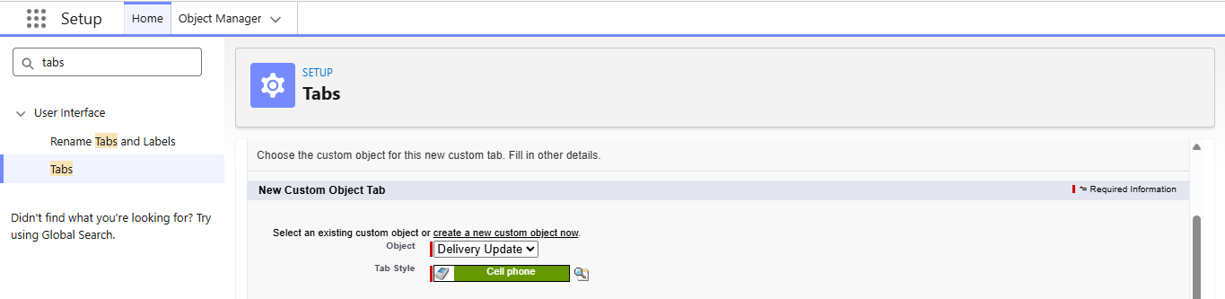

Activity 6: Creating a Tab for Invoice Object
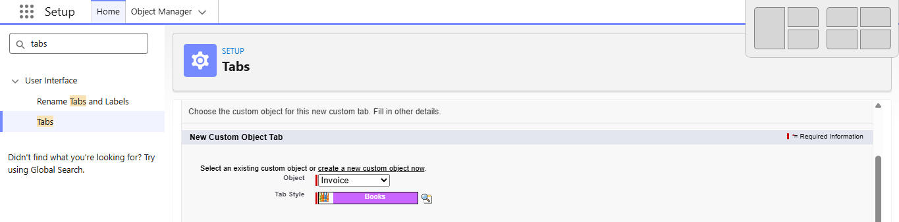

Milestone 4: Fields & Relationships

Activity 1: Creation of fields for the Customer Object
Field Name | API Name | Data Type | Required | Description
Customer Name | Name | Text | Yes | Full name of customer
Email | Email__c | Email | Yes | Customer email
Phone | Phone__c | Phone | Yes | Customer contact number
Address | Address__c | Text Area | Yes | Customer address

Customer Type | Customer_Type__c | Picklist | Yes | Regular / Business
City | City__c | Text | No | Customer city
State | State__c | Text | No | Customer state
Pincode | Pincode__c | Text | No | Postal code
Is Active | Is_Active__c | Checkbox | No | Active status
1. Email (Email Field)
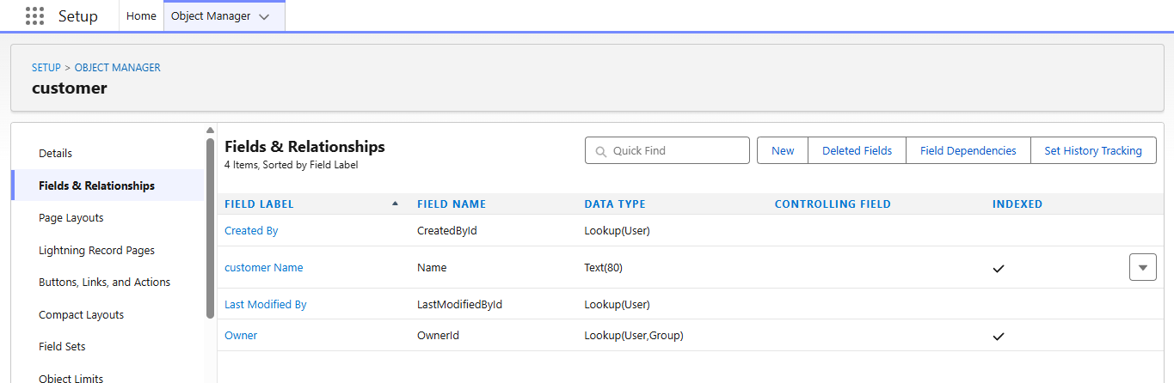
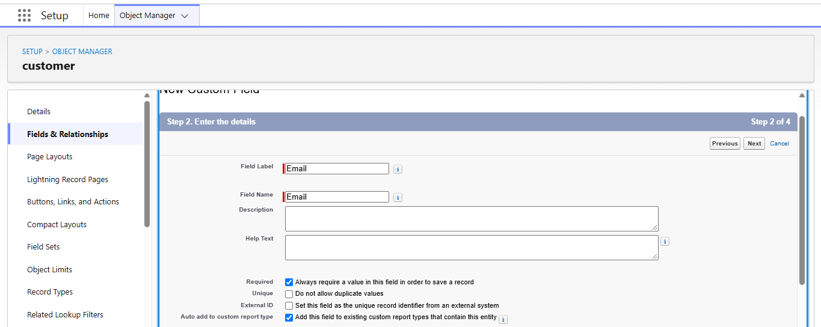
2. Phone (Phone Field)
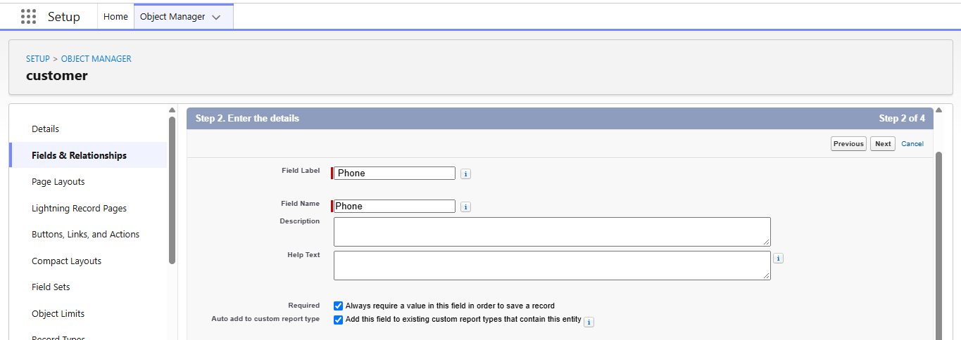
3. Address (Text Area)
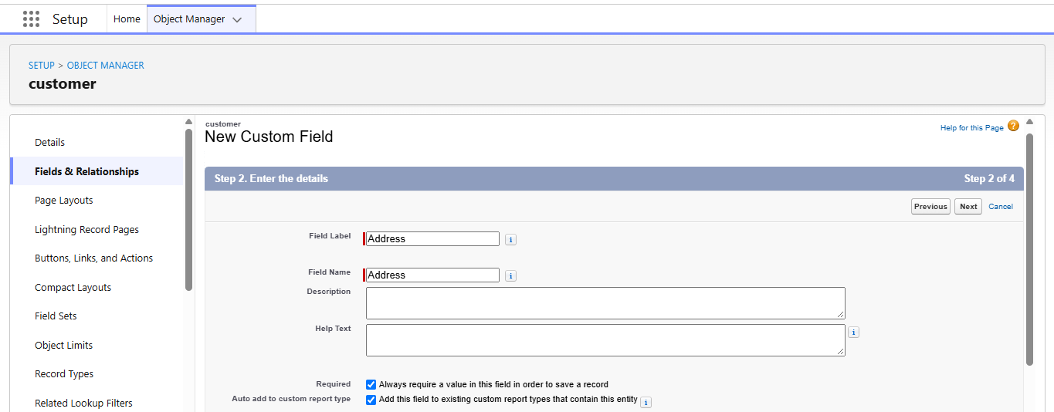
4. Customer Type (Picklist)
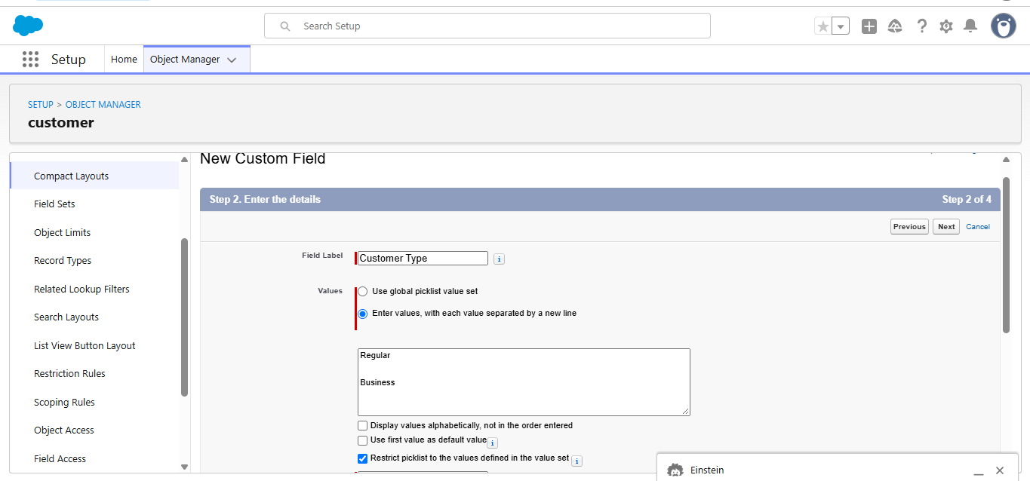
5. City (Text)
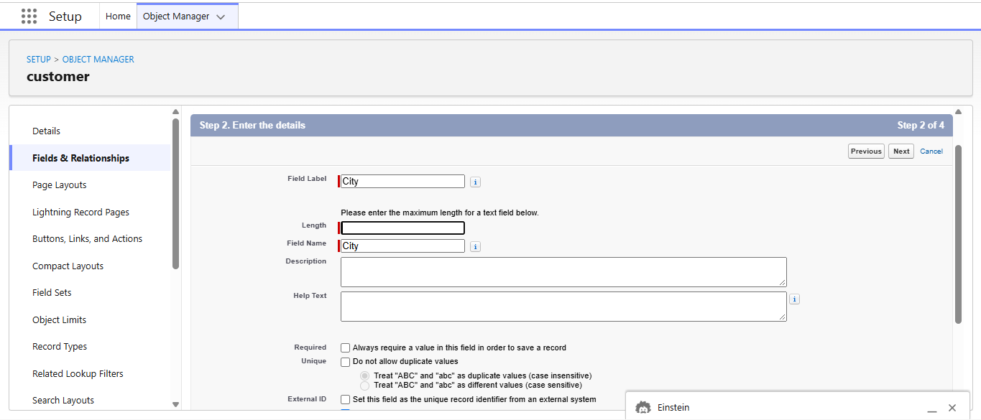
6. State (Text)
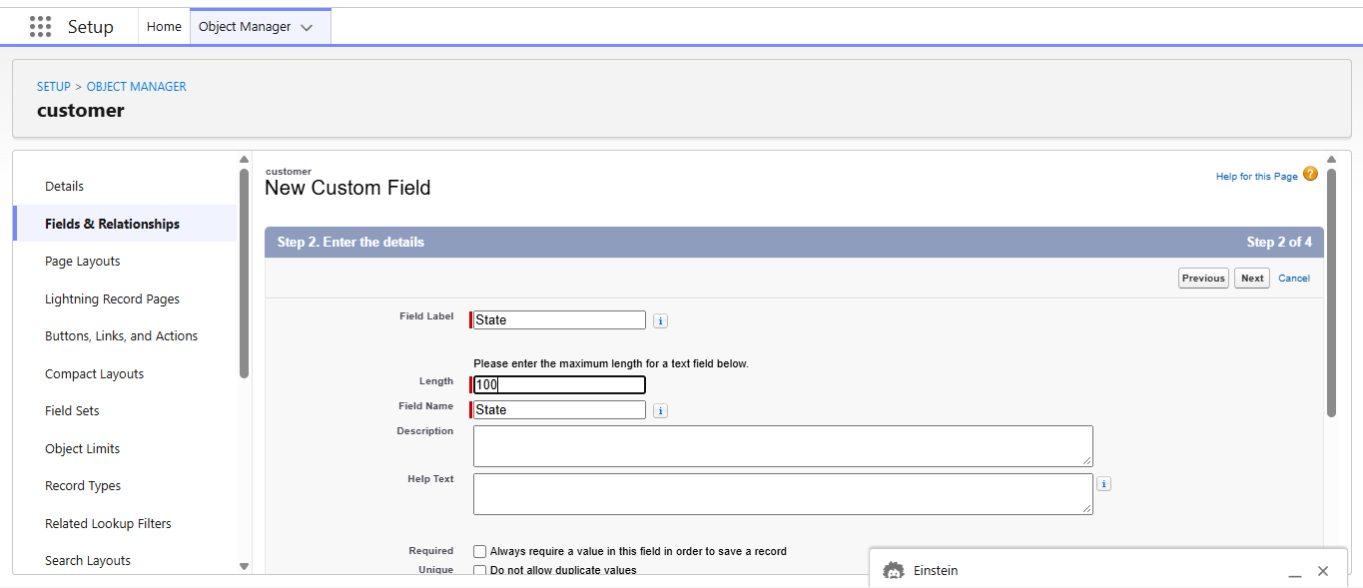
7. Pincode (Text)
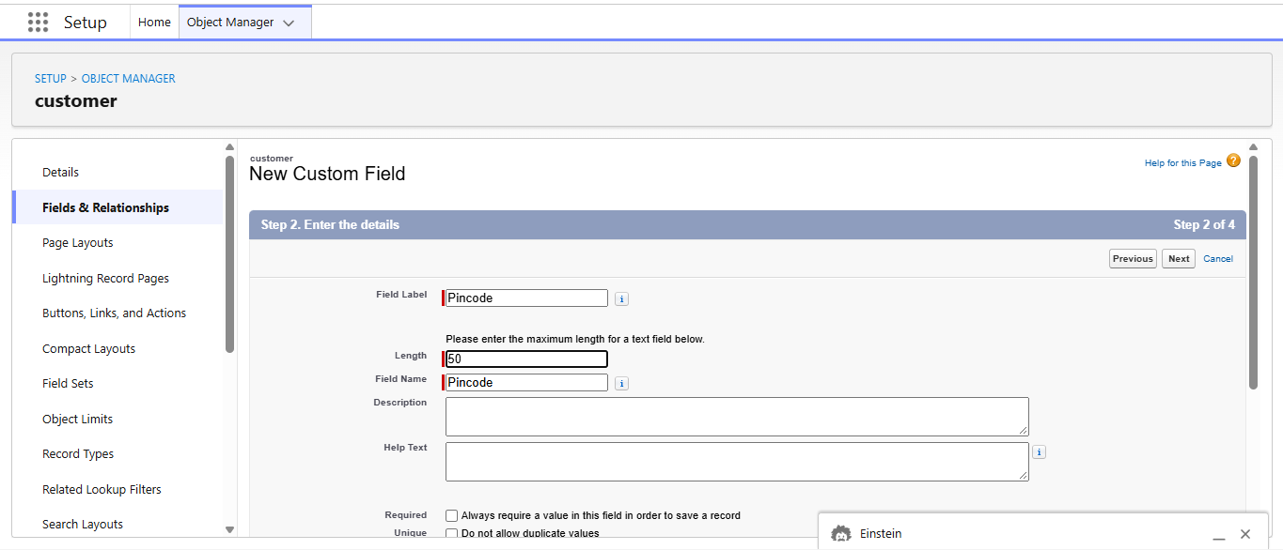
8. Is Active (Checkbox)
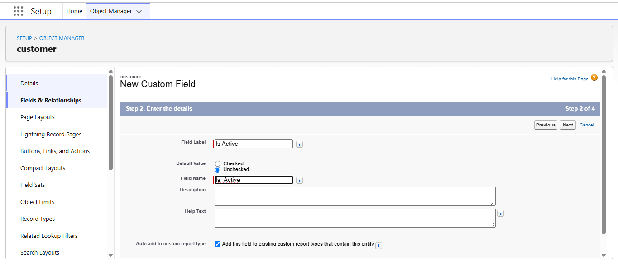

Activity 2: Creation of fields for the Shipment Object
Field Name | API Name | Data Type | Required | Description
Tracking Number | Name | Auto Number | Yes | Unique ID

Customer | Customer__c | Lookup(Customer) | Yes | Related customer
Source Address | Source_Address__c | Text Area | Yes | Pickup location
Destination Address | Destination_Address__c | Text Area | Yes | Delivery location
Weight | Weight__c | Number | Yes | Parcel weight
Price | Price__c | Currency | Yes | Shipping charge
Status | Status__c | Picklist | Yes | Shipment status
Expected Date | Expected_Date__c | Date | Yes | Delivery estimate
Assigned Agent | Assigned_Agent__c | Lookup(Delivery_Agent) | No | Delivery agent
Shipment Type | Shipment_Type__c | Picklist | Yes | Domestic/International

1. Source Address (Text Area)

